How to Donate to CRMF using
Fred Meyers Rewards & Smile.Amazon.com

Thank you to the twelve families who shop at Fred Meyer and have designated the Columbia River MOAA Foundation as recipients of your Rewards donation dollars. This year we have received $47.62 to date. It’s easy to support the foundation this way. All you do is get a Rewards Card at the Customer Service desk and then link it to the Columbia River MOAA Foundation (Fred Meyer fund number AU238). After that, just tell the checker your phone number (or type it in yourself if) at checkout. Hope to see more of you doing this method. What could be simpler?

Maybe Smile.Amazon.com is simpler! We are now registered with Smile.Amazon.com so when you shop online at Amazon our Foundation receives money! To get started, click on our unique charity link, which takes you directly to smile.amazon.com where you are automatically asked if you want to support Columbia River Moaa Foundation--CRMF. Our unique charity link is: https://smile.amazon.com/ch/47-4776049.

This is simple and painless. For future purchases though, you must use smile.amazon.com and NOT Amazon prime (same company, same products, you just need to use this web address). I have saved smile.amazon.com as a favorite on my browser, so I will remember to use it for all my online Amazon purchases,. Hope you will also.

Sample pages that you will see:

Welcome to AmazonSmile!
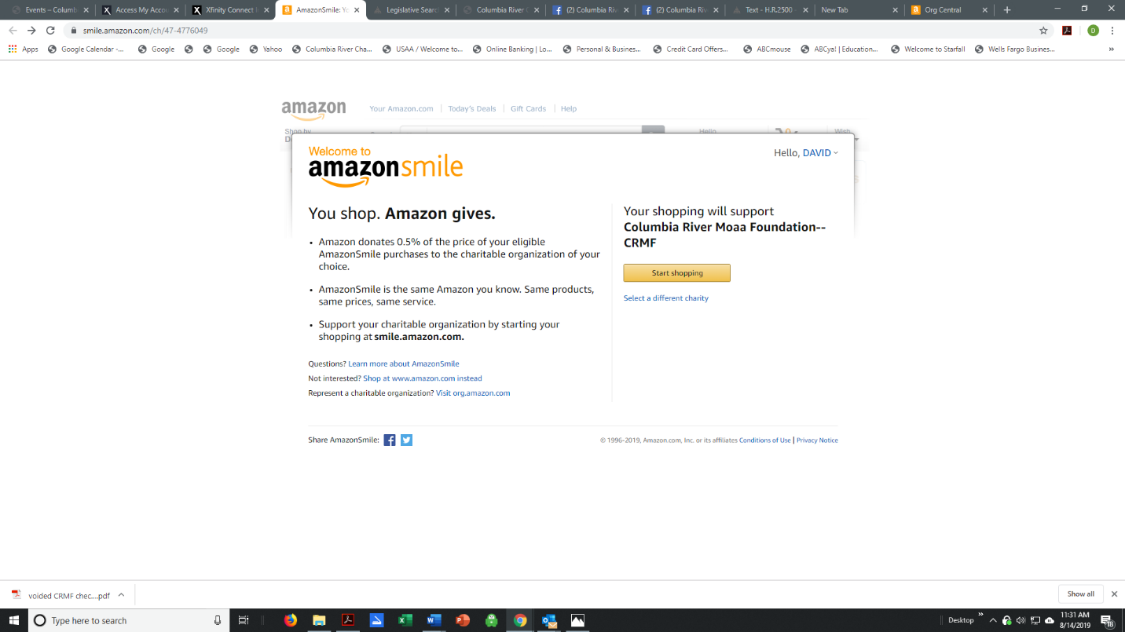
Hello, DAVID

You shop. Amazon gives.
- Amazon donates 0.5% of the price of your eligible AmazonSmile purchases to the charitable organization of your choice.

